CONGRATULATIONS to our own GERRY STIFFLER (Baypines District United Methodist Women’s President) for winning the 2019 ALICE LEE AWARD at the Alabama West Florida United Methodist annual Conference.

The Commission on the Status and Role of Women (COSROW) of the Alabama – West Florida Conference annually presents the Alice Lee Award at Annual Conference. The coveted award is named for outstanding Monroeville attorney and church leader Alice Lee.

Miss Lee was the first woman to chair the conference delegation to General Conference and is to date the only woman to do so. The award was established to help promote COSROW’s primary purpose of “challenging the church to a continuing commitment to the full and equal responsibility and participation of women in the total life and mission of the church, sharing fully in the power and in the policy making at all levels of the Church life.” Women who have been the recipients of the Alice Lee Award have not only demonstrated commitment to God and their church, but have also been bridge builders and barrier breakers for women through their leadership in the church and community.

**Geraldine Stiffler** is known in her community as a business woman, Chamber member, Rotary Club member, Theater worker, Hospice worker and general go getter for South Baldwin County.

In her church work **she is Baypines District President of UMW**, Foley UMC COSROW Chair, membership secretary, and on the Galilean Committee which provides worship services at Gulf State Park from Mother’s Day until Labor Day.  She also works with youth and children’s programs, AWFC: Episcopacy Committee, and an Annual conference member.

Gerry says that her gift is “getting people to do things”.  Truly it is.  Foley Kids Corner is a fundraiser held at Foley UMC for missions which involved the South Baldwin Community coming together.  Also the Lenten Lunches have been held community-wide for a number of years.   The mission is “We’re working together to make our community great by understanding one another.”

She is a very busy and involved person with a calling to get things.  She makes a difference, as only she can, wherever she is participating.

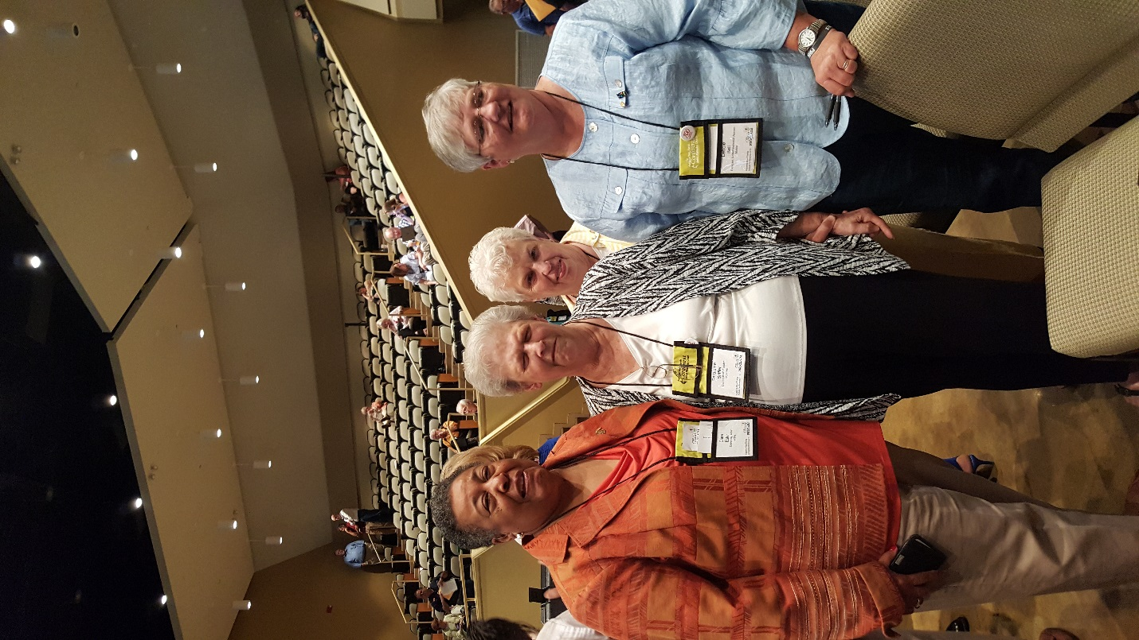*Taken from the* [*www.awfumc.org/newsdetail*](http://www.awfumc.org/newsdetail) *website.*